Hi, this is a project and it is a fat Android phone and prototype.

Title Cupcake Food.

Brigett Hurley aka Brigida

29015 North 64Th Place

Cave Creek, AZ. 85331

480-400-2734

The project is 15 months. Supporting the arts. A challenging game levels beginning, intermediate and advance. A test analysis on customers and survey to determine reviews and comments. Out of five star review, predictions at 4 stars with 65K, comments.











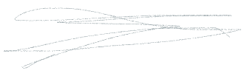







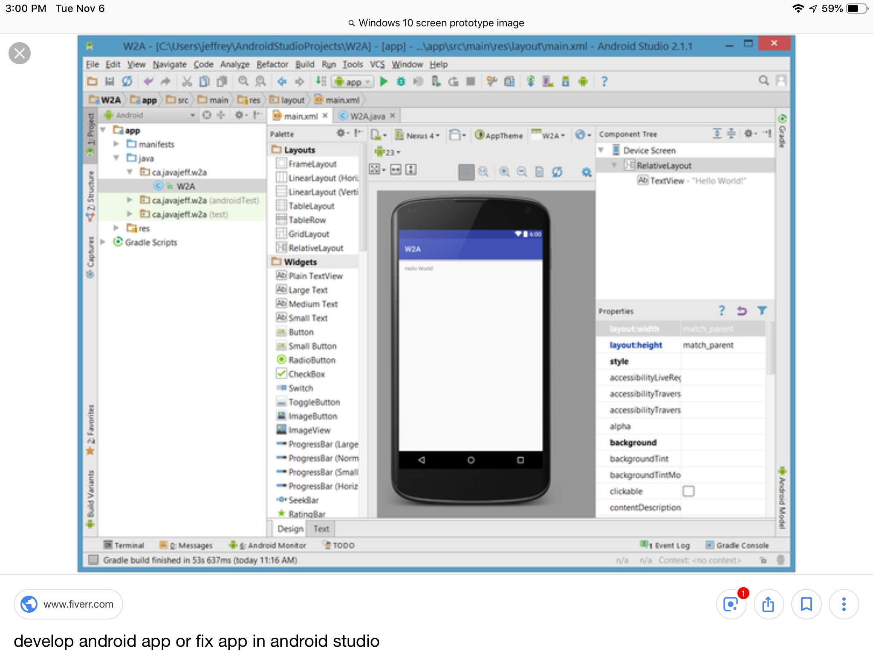



Wireframe

Sign up and it sets to Auto on, sound on, songs on and music lyrics on. Latin, hip hop, and pop. Ages 2 + Get app and download software, Android devices.

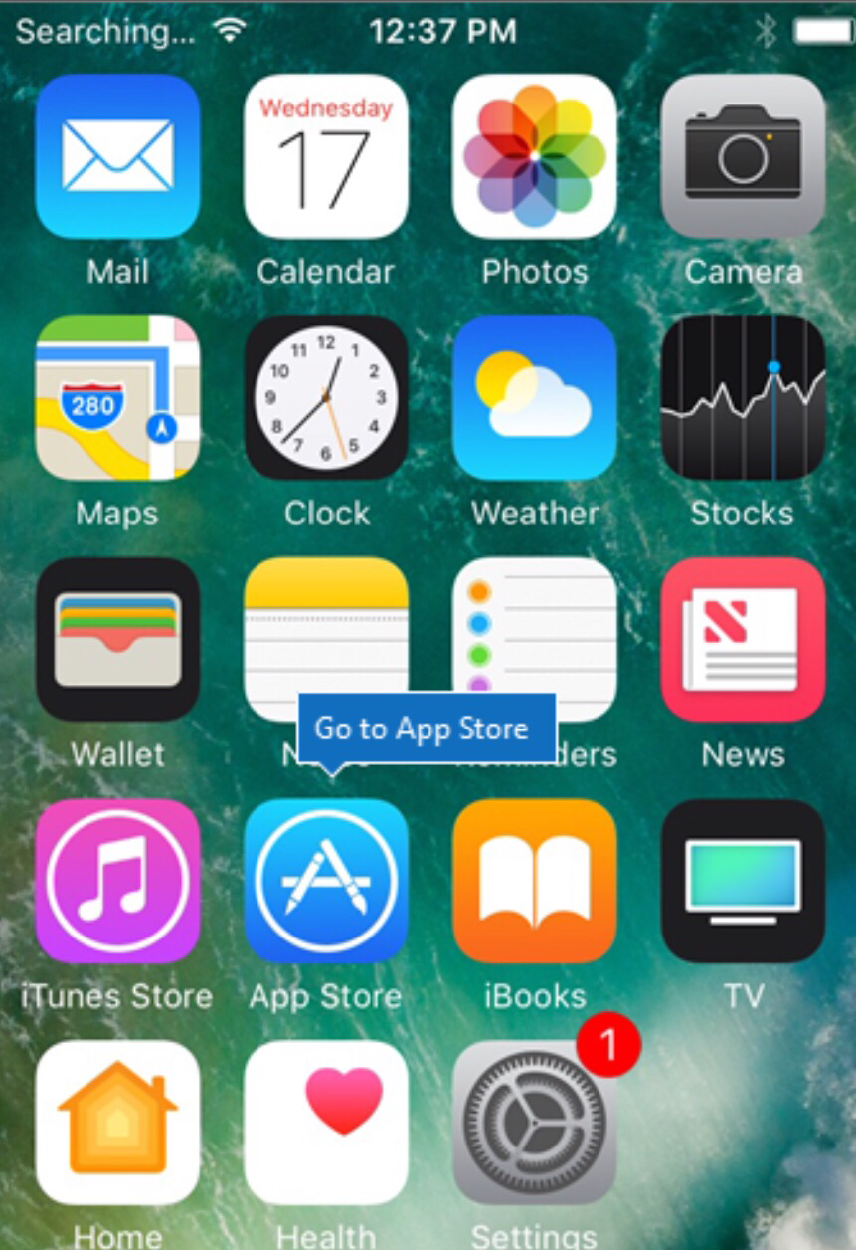Android prototype

Two player opponent both avatars 2D animated. Profile on user. Developer Boo Hurley. Trophies, awards, stickers, increase energy to throw ball. Based on distance, math, balance, digital, how far can you throw a cupcake. Cupcake piles up. Put in can, mixed with milk, chicken, and chips. and winner eats at table.

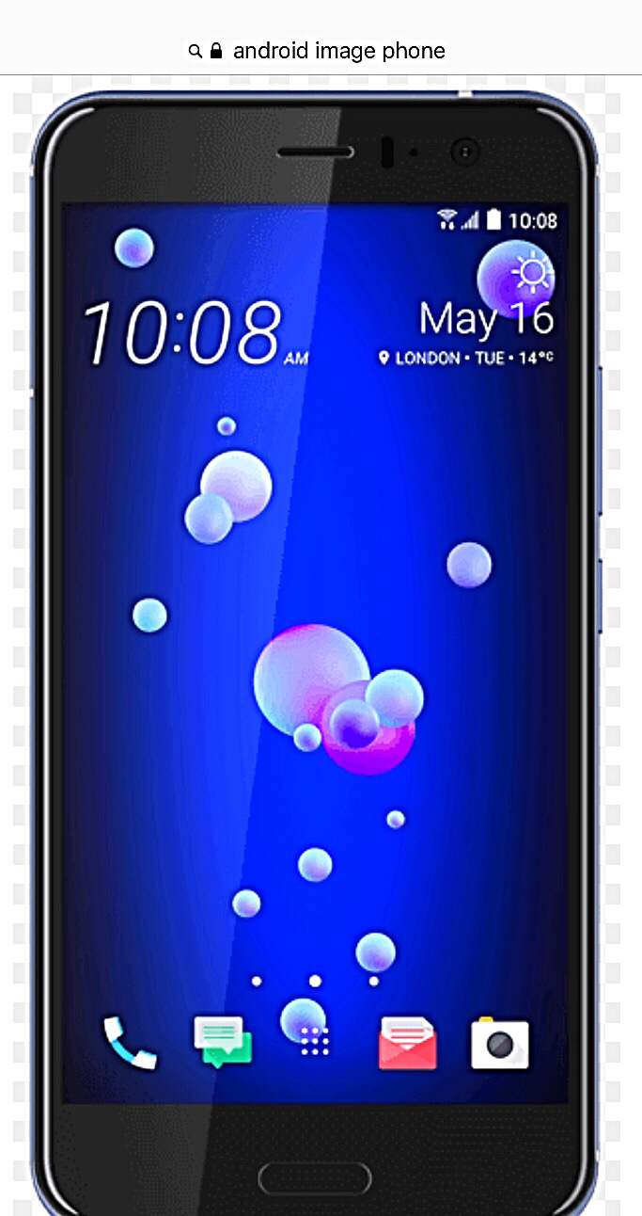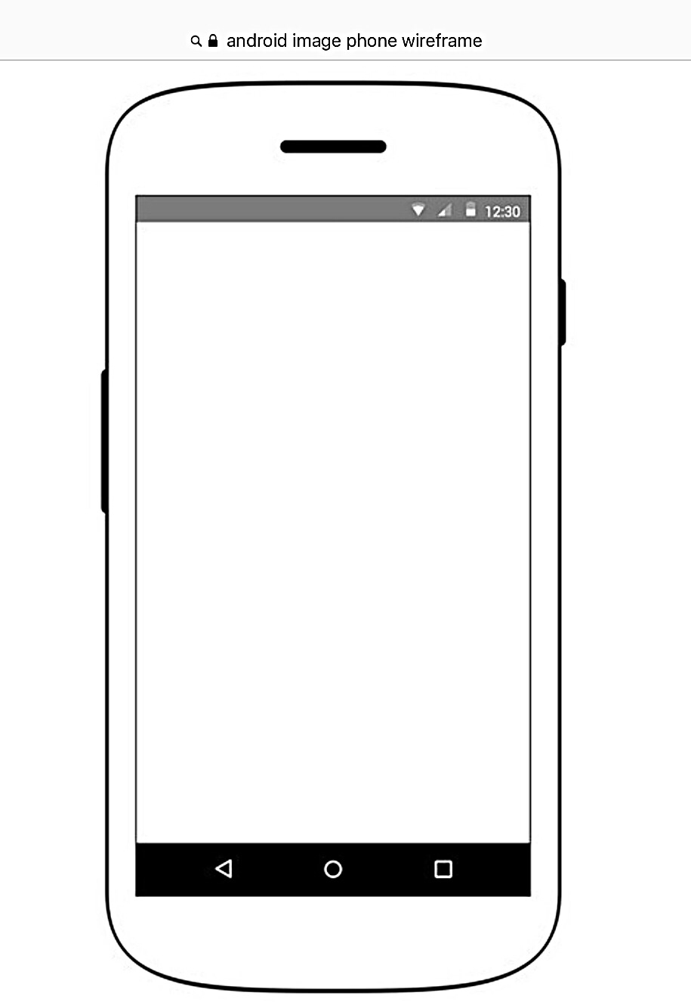Android phone

Profile avatar animated 2D on one and opponent is a guest, user or robot. All ready data configured.



Avatars for opponent are trends, fashion, economy

Avatar user profile are on career, jobs and profession. The avatars are dressed up 100 Avatars, random selection for robot. Selection for opponent, guest and friends. Shared app on app sign up and Facebook, optional.



Data, graphs and charts

